**Create a Spring Web Project using Maven**

**Results and Outputs :**

**a :**

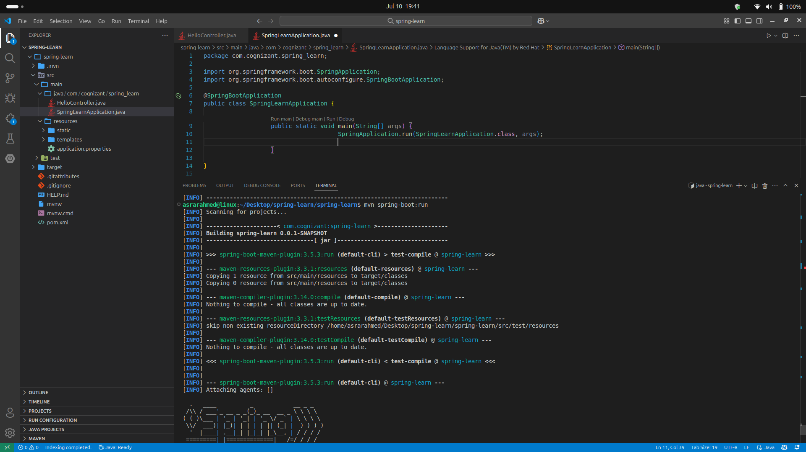

**b :**

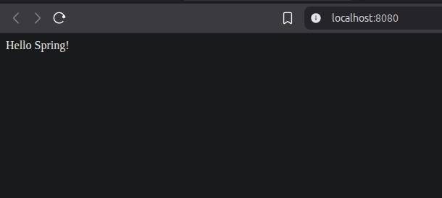

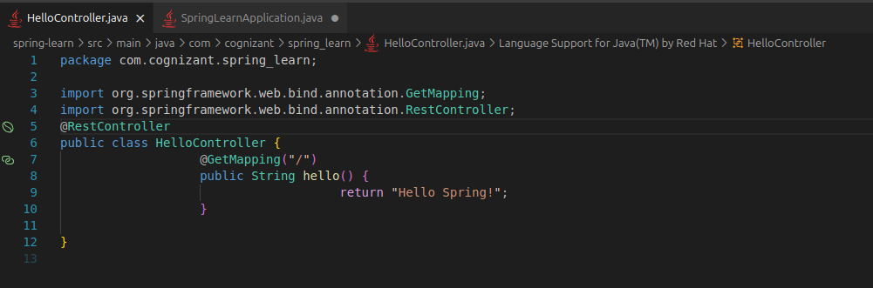**c :**